**Practical No: 3**

**Decision Making and Looping statements.**

**AIM: A) Create an automation UiPath Project using Decision Making** **statements.**

**Steps with output**

1. **If**
2. Drag and drop an "Input Dialog" activity into the sequence.A screenshot of a computer

   Description automatically generated
3. Drag and drop an "If" activity below the "Input Dialog" activity.
4. Add a "Message Box" Activity (Then Branch):

1. Add a "Message Box" Activity (Else Branch)A screenshot of a computer

   Description automatically generated

Output:

1. **Else IF**
2. Drag and drop an "Input Dialog" activity into the sequence**.**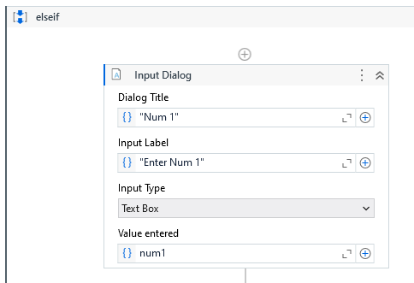
3. Add a "Message Box"  
   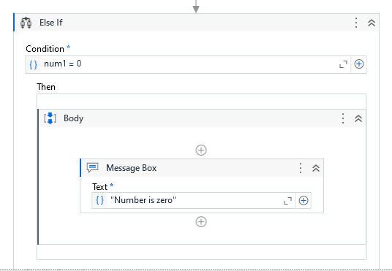 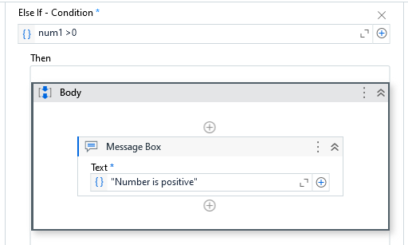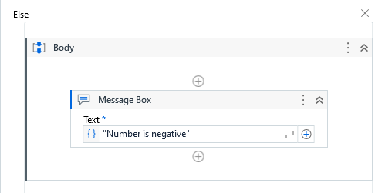

**OUTPUT:**

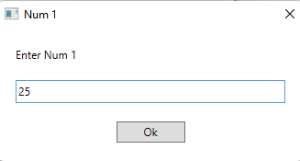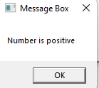

**AIM: B) Create an automation UiPath Project using looping statements**

**Steps with output**

1. **While Loop**
2. Add while activity and set condition to -> count <=5

1. Create variable count and set variable type to int32  
   A white rectangular object with black lines

   Description automatically generated
2. Inside while body create message box and write message -> "Current Count: " + count.ToString()  
   A screenshot of a computer

   Description automatically generated
3. Drag and drop assign activity inside while   
   Set the "To" field to Count.

Set the "Value" field to Count + 1.

**OUTPUT**

1. **Do While**
2. Do While Loop: Drag and drop a "Do While" activity from the "Activities" panel into your workflow.

1. Create a variable named ‘Count’ of type "Int32" to keep track of the current count.

1. we will use the condition: Count <= 5. This means the loop will continue as long as the Count variable is less than or equal to 5.
2. Inside the "Do While" activity, drag and drop a "Message Box" activity.

1. Configure the Message Box Activity:  
   A screenshot of a computer

   Description automatically generated
2. Add an "Assign" activity inside the "Do While" loop:

Set the "To" field to Count.

Set the "Value" field to Count + 1.

**OUTPUT**

1. **FOR EACH**

we'll create a "For Each" loop to iterate through a list of names and display each name using a message box.

1. Add a List of Names:

1. In the "Default" value field of the variable, enter the list of colors enclosed in curly braces {} and separated by commas.

1. Drag and drop a "For Each" activity from the "Activities" panel into your workflow.

1. Inside the "For Each" activity, drag and drop a "Message Box" activity.



OUTPUT:

